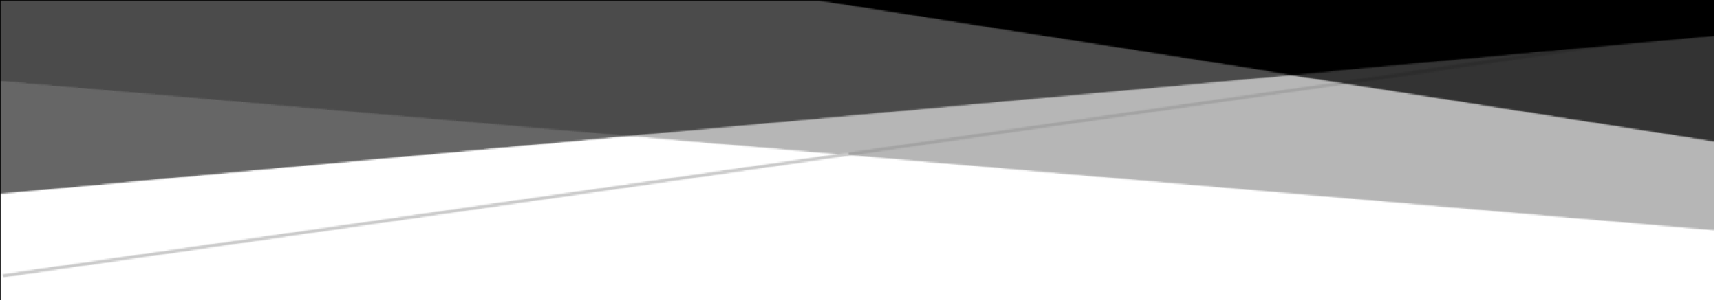

IOT-CENTRIC ANIMAL INTRUSION DEVICE

Abstract

In this report, we explore the design and implementation of an IoT-centric ANIMAL INTRUSION DEVICE .

**SURYODYA COLLEGE OF ENGINEERING AND**

**TECHNOLOGY**

NAGPUR,MH-440027



**PROJECT REPORT**

**ON**

“**IOT-CENTRIC ANIMAL INTRUSION DEVICE**”

***Submitted in partial fulfillment of the requirements***

***for the award of degree***

## BACHLOR OF TECHNOLOGY

Submitted by

* **SIDDHARTH PARIHAR**
* **ROHIT KUHITE**
* **YASH DANTULE**
* **VEDANT KALAMBE**

### **UNDER THE GUIDANCE OF**

**Mr. Nazmul Arefin , Mr. Mani Shankar & Mr. Sumit Chafle**

**Advisors,**

Dept of CSED, Nagpur, Maharashtra

**2022-2023**

**2022-2023**

**NAGPUR, MAHARASHTRA - 440027**

## CERTIFICATE

Certified that the project work entitled “**ANIMAL INTRUSION DEVICE**

**IOT-CENTRIC”** carried out by **Mr. SIDDHARTH PARIHAR,** bearing,a bonafide student of **Computer Engineering, Suryodaya College of Engineering and Technology,** in the

partial fulfilment for the award of degree **Bachelor of Technology** in **Computer Engineering**

during the year **2022-2023.** It is certified that all corrections/suggestions indicated for Internal Assessment have been incorporated in the report. The project report has been approved as it satisfies the academic requirements in respect of project work prescribed for the said Degree.

Signature of Guide Signature of HOD Signature of Principal

Mr. Sumit Chafale Mr. Vijay Nagpurkar Dr. Shri. V. G. Arajpure

### External Viva

Name of the Examiners Signature with date

1………………………. ………………………...

2……………………….. …………………………

**2022-2023**

**NAGPUR, MAHARASHTRA - 440027**

## CERTIFICATE

Certified that the project work entitled “**ANIMAL INTRUSION DEVICE**

**IOT-CENTRIC”** carried out by **Mr.ROHIT KUHITE,** bearing,a bonafide student of **Computer Engineering, Suryodaya College of Engineering and Technology,** in the

partial fulfilment for the award of degree **Bachelor of Technology** in **Computer Engineering** during the year **2022-2023.** It is certified that all corrections/suggestions indicated for Internal Assessment have been incorporated in the report. The project report has been approved as it satisfies the academic requirements in respect of project work prescribed for the said Degree.

Signature of Guide Signature of HOD Signature of Principal

Mr.Sumit Chafale Mr.Vijay Nagpurkar Dr. Shri. V . G. Arajpure

### External Viva

Name of the Examiners Signature with date

1………………………. ………………………...

2……………………….. ………………………… **2022-2023**

**NAGPUR, MAHARASHTRA - 440027**

**2022-2023**

**NAGPUR, MAHARASHTRA - 440027**

## CERTIFICATE

Certified that the project work entitled “**ANIMAL INTRUSION DEVICE**

**IOT-CENTRIC”** carried out by **Mr. YASH DANTULE,** bearing,a bonafide student of **Computer Engineering, Suryodaya College of Engineering and Technology,** in the

partial fulfilment for the award of degree **Bachelor of Technology** in **Computer Engineering** during the year **2022-2023.** It is certified that all corrections/suggestions indicated for Internal Assessment have been incorporated in the report. The project report has been approved as it satisfies the academic requirements in respect of project work prescribed for the said Degree.

Signature of Guide Signature of HOD Signature of Principal

Mr.Sumit Chafale Mr.Vijay Nagpurkar Dr. Shri. V . G. Arajpure

### External Viva

Name of the Examiners Signature with date

1………………………. ………………………...

2……………………….. ………………………… **2022-2023**

**NAGPUR, MAHARASHTRA - 440027**

**2022-2023**

**NAGPUR, MAHARASHTRA - 440027**

## CERTIFICATE

Certified that the project work entitled “**ANIMAL INTRUSION DEVICE**

**IOT-CENTRIC”** carried out by **Mr. VEDANT KALAMBE,** bearing,a bonafide student of **Computer Engineering, Suryodaya College of Engineering and Technology,** in the

partial fulfilment for the award of degree **Bachelor of Technology** in **Computer Engineering** during the year **2022-2023.** It is certified that all corrections/suggestions indicated for Internal Assessment have been incorporated in the report. The project report has been approved as it satisfies the academic requirements in respect of project work prescribed for the said Degree.

Signature of Guide Signature of HOD Signature of Principal

Mr.Sumit Chafale Mr.Vijay Nagpurkar Dr. Shri. V . G. Arajpure

### External Viva

Name of the Examiners Signature with date

1………………………. ………………………...

2……………………….. ………………………… **2022-2023**

**CONTENTS PAGE NO.**

1. **ABSTRACT 7**
2. **PROBLEM STATEMENT 8**
3. **COMPONENTS USED 9-17**
   1. ULTRASONIC : UNDERSTANDING ITS SIGNIFICANCE
   2. SERVO MOTOR : UNDERSTANDING ITS SIGNIFICANCE
   3. BUZZER AND I2C LCD: UNDERSTANDING ITS SIGNIFICACE
   4. ESP8266 BOARD: UNDERSTANDING ITS SIGNIFICANCE
4. **DATA MANAGEMENT WITH THINGWORX 18-19**
   1. Data Collection and Ingestion
   2. Data Storage and Persistence
   3. Data Processing and Analytics
   4. Data Visualization and Dashboards
   5. Data Access and Integration
   6. Data Security and Governance
5. **DEVICE 20**
6. **CONCLUSION 21**

**1.ABSTRACT**

In this report, we explore the design and implementation of an IoT-centric Animal Intrusion Device, An animal intrusion device designed to prevent animals from entering restricted areas. The device incorporates two ultrasonic sensors, a servo motor for sensor rotation, a buzzer to deter animals, and an I2C LCD for real-time feedback.

The dual ultrasonic sensors are strategically positioned to detect the presence of animals within a specified range. By leveraging ultrasonic technology, the device accurately measures the distance between the sensors and the animals, enabling efficient detection and response. The servo motor enables the sensors to rotate horizontally, expanding the coverage area and ensuring comprehensive animal monitoring.

In the event of an animal intrusion, the device activates a high-intensity buzzer, emitting a deterrent sound that discourages animals from approaching the protected zone. Additionally, an I2C LCD display is integrated to provide instant visual feedback, displaying relevant information such as sensor readings, system status, and any detected animal activity.

The animal intrusion device operates on a microcontroller-based system, capable of processing the sensor data and triggering the appropriate response mechanisms. The device can be easily configured and customized to suit specific environmental requirements, allowing for flexible deployment in various settings such as farms, gardens, and wildlife protection areas.

Through the integration of dual ultrasonic sensors, a servo motor for rotation, a buzzer for auditory deterrence, and an I2C LCD for visual feedback, the animal intrusion device offers an effective and versatile solution for deterring animals and protecting restricted areas. Its reliable detection capabilities and configurable nature make it an ideal choice for mitigating human-wildlife conflicts and maintaining safety in animal-sensitive environments.

### **2.PROBLEM STATEMENT**

The presence of animals in restricted areas poses a significant challenge in maintaining safety and preventing damage to property. Current solutions for deterring animal intrusions often lack accuracy, coverage, and real-time feedback, leading to ineffective prevention measures. Therefore, there is a need for an advanced animal intrusion device that combines reliable detection, comprehensive coverage, and immediate deterrent measures.

The specific problems to address are as follows:

1. Inadequate Detection: Existing animal intrusion devices often rely on a single sensor, limiting their ability to accurately detect animals within a wide area. This can result in missed intrusions or false alarms, compromising the effectiveness of the system.
2. Limited Coverage: Without the capability to rotate the sensors, existing devices have a fixed detection range, leaving blind spots that animals can exploit to enter restricted areas undetected. This restricts the device's applicability to larger areas or environments with irregular layouts.
3. Absence of Effective Deterrence: Many current solutions lack a deterrent mechanism to actively discourage animals from approaching restricted areas. Without an effective deterrent, animals may persist in attempting to breach the boundaries, leading to potential damage or safety hazards.
4. Lack of Real-time Feedback: The absence of a visual feedback system hinders real-time monitoring and assessment of the device's performance. Immediate feedback on detected animal activity, sensor readings, and system status is crucial for timely response and fine-tuning of the intrusion prevention strategy.

To address these problems, an animal intrusion device with two ultrasonic sensors, a servo motor for rotation, a buzzer for deterrent sound, and an I2C LCD for real-time feedback is proposed. This device aims to improve detection accuracy, expand coverage area, provide effective deterrence, and offer comprehensive monitoring through visual feedback. By doing so, it will contribute to mitigating animal intrusions, protecting restricted areas, and enhancing overall safety and security.

**3.COMPONENTS USED**

**3.1 ULTRASONIC SENSOR: UNDERSTANDING ITS SIGNIFICANCE**

Ultrasonic sensors are commonly used in various applications, including distance

measurement, object detection, and intrusion prevention. In the proposed animal

intrusion device, ultrasonic sensors play a vital role in detecting the presence

of animals and providing accurate distance measurements. Here is some

information about ultrasonic sensors and how they will be used in the device:

1. **Working Principle**:

Ultrasonic sensors emit high-frequency sound waves, typically above the human

hearing range, and then measure the time it takes for the sound waves to bounce

back after hitting an object. By calculating the time of flight, the sensor can determine

the distance between the sensor and the object.

1. **Sensor Configuration:**

The device incorporates two ultrasonic sensors, positioned at strategic

locations to ensure comprehensive coverage of the protected area.

The sensors are typically mounted facing outward, enabling them to detect

any animal movement within their range.

1. **Detection Range:**

Ultrasonic sensors have a maximum detection range that varies depending

on the specific sensor model. The detection range can typically extend

up to several meters, allowing for efficient monitoring of a significant area.

1. **Distance Measurement:**

When an animal enters the detection range of the ultrasonic sensors, they

1. **Triggering Deterrent Mechanisms:**

Upon detecting an animal within the specified range, the microcontroller of the

device can trigger the activation of deterrent mechanisms such as the buzzer.

The ultrasonic sensors provide the necessary input to initiate the deterrence

process, alerting the animal and discouraging it from approaching further.

1. **Coverage Enhancement:**

To ensure a comprehensive monitoring solution, the ultrasonic sensors are

connected to a servo motor. This motor enables the sensors to rotate

horizontally, expanding their coverage area. By rotating the sensors, blind

spots can be minimized, and a wider area can be monitored effectively.

**In summary**, ultrasonic sensors in the animal intrusion device provide

accurate distance measurements and detection of animals within their

range. They form the foundation of the device's detection system,

enabling the triggering of deterrent mechanisms and contributing to

comprehensive monitoring by rotating the sensors.

emit sound waves that bounce back to the sensors upon hitting the animal.

By measuring the time it takes for the sound waves to return, the sensor

can accurately calculate the distance between the sensor

and the animal.

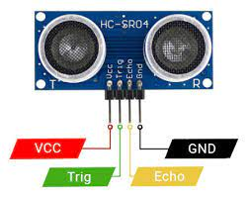

**3.2 SERVO MOTOR: UNDERSTANDING ITS SIGNIFICANCE**

A servo motor is a type of motor that is commonly used in robotics and automation applications.

In the animal intrusion device, a servo motor is employed to rotate the ultrasonic sensors, enabling

the expansion of the coverage area and ensuring comprehensive monitoring. Here is some information

about the servo motor and how it is used in the device:

1. **Servo Motor Function:**

A servo motor is a closed-loop control system that consists of a motor, a feedback device

such as a potentiometer or an encoder), and a control circuit. It is designed to precisely control

the position, speed, and torque of the motor shaft.

1. **Rotation Mechanism:**

The servo motor in the animal intrusion device is connected to the ultrasonic sensors and is responsible

for their rotation. By receiving control signals from the microcontroller, the servo motor can accurately

the sensors horizontally, covering a wider area and reducing blind spots.

1. **Control Signals:**

The microcontroller in the device generates control signals that are sent to the servo motor to specify

the desired position of the sensors. These control signals determine the angle of rotation for the servo

motor, allowing it to move the sensors to different positions within the designated range.

1. **Adjustable Rotation Range:**

The rotation range of the servo motor can be adjusted based on the specific requirements of the application.

This allows for customization and optimization of the coverage area, ensuring that the sensors cover the

desired monitoring zone effectively.

1. **Synchronization with Sensor Data:**

The rotation of the servo motor is synchronized with the sensor data. As the sensors detect the presence

of animals and provide distance measurements, the servo motor can dynamically adjust the position of

the sensors to track and monitor the animal's movement within the covered area.

1. **System Integration**:

The servo motor is integrated into the overall control system of the device, working in conjunction with

the ultrasonic sensors, microcontroller, and other components. This integration enables precise

control and coordination of the sensors' rotation, enhancing the accuracy and effectiveness of the animal intrusion detection system.

**In summary,** the servo motor in the animal intrusion device facilitates the rotation

of the ultrasonic sensors, expanding the coverage area and reducing blind spots.

It receives control signals from the microcontroller and can adjust the position

of the sensors to track animal movement effectively. By incorporating the servo

motor, the device ensures comprehensive monitoring and improves the overall

performance of the intrusion prevention system.

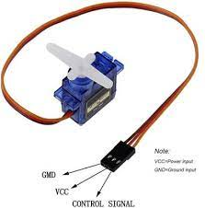

**3.3 Buzzer and I2C LCD: UNDERSTANDING ITS SIGNIFICANCE**

In the animal intrusion device, a buzzer and an I2C LCD are additional components that contribute to the overall functionality and user experience. Here's how they are used in the device:

**Buzzer:**

1. Deterrent Sound:

The buzzer is used to emit a deterrent sound when an animal intrusion is detected. Upon receiving a trigger signal from the microcontroller, the buzzer generates a high-intensity sound that is unpleasant for animals, effectively discouraging them from approaching the protected area.

1. Auditory Warning:

The sound produced by the buzzer serves as an audible warning for both the animals and the humans present in the vicinity. It alerts them to the presence of a restricted zone and encourages them to maintain a safe distance.

1. Configurable Settings:

The device may provide options for configuring the buzzer's sound frequency, duration, and volume. This flexibility allows for customization based on the specific needs of the environment and the targeted animals.

**I2C LCD**:

1. Real-time Feedback:

The I2C LCD (Inter-Integrated Circuit Liquid Crystal Display) is used to provide real-time feedback and information to the user. It displays relevant data such as sensor readings, system status, and detected animal activity.

1. Visual Monitoring:

The LCD display allows for immediate visual monitoring of the device's operation and any detected animal intrusions. Users can quickly assess the situation without relying solely on auditory cues or manual inspection.

1. User Interface:

The LCD screen may also serve as an interface for configuring and adjusting device settings. Users can access menus and options displayed on the LCD to customize parameters, sensitivity levels, or other operational aspects of the intrusion prevention system.

1. Status Indicators:

The LCD can display system status indicators, providing a visual representation of the device's operational state. This includes indicators for power status, connectivity, sensor functionality, and any system errors or malfunctions.

By incorporating a buzzer and an I2C LCD, the animal intrusion device enhances its deterrent capabilities and provides users with valuable real-time feedback. The buzzer effectively deters animals, while the LCD display offers a user-friendly interface for monitoring, customization, and system status indication. Together, these components contribute to the overall effectiveness and usability of the animal intrusion prevention system.

##### 

##### 

##### 

* 1. **ESP8266 BOARD: UNDERSTANDING ITS SIGNIFICANCE**

The ESP8266 is a popular and widely used Wi-Fi-enabled microcontroller board. It integrates a microcontroller unit (MCU) with built-in Wi-Fi capabilities, making it suitable for Internet of Things (IoT) applications. Here is some information about the ESP8266 board:

Features:

The ESP8266 board offers several key features:

Microcontroller: It is equipped with a powerful 32-bit MCU, often based on the Xtensa architecture, running at a clock speed of up to 80 MHz.

Wi-Fi Connectivity: The board has built-in Wi-Fi capabilities, allowing it to connect to wireless networks and communicate with other devices or the internet.

GPIO Pins: It offers a range of general-purpose input/output (GPIO) pins, which can be used to interface with various sensors, actuators, and other peripherals.

Memory: The board typically provides both program storage flash memory and RAM for data storage and execution.

Low Power Consumption: The ESP8266 is designed to operate efficiently, with various low-power modes to conserve energy.

Programming:

The ESP8266 board can be programmed using various development environments and programming languages, including Arduino IDE, MicroPython, and Lua scripting language. It offers extensive libraries and APIs that simplify the development process.

Wi-Fi Functionality:

The integrated Wi-Fi capabilities enable the ESP8266 board to connect to Wi-Fi networks, both as a client and as an access point. It supports common Wi-Fi protocols such as TCP/IP, UDP, HTTP, MQTT, and more. This makes it suitable for applications that require remote monitoring, control, or data transmission over the internet.

Expansion and Interfaces:

The board usually provides multiple communication interfaces, including serial communication (UART), I2C, SPI, and GPIO pins. These interfaces enable the connection of external devices and modules such as sensors, displays, relays, and other peripherals.

Community Support:

The ESP8266 has a large and active community of developers and enthusiasts. This community has contributed to a vast ecosystem of resources, tutorials, libraries, and projects, making it easier to get started and find support for various applications.

Cost-effectiveness:

One of the notable advantages of the ESP8266 board is its affordability. It offers powerful features and Wi-Fi connectivity at a relatively low cost, making it a popular choice for hobbyists, DIY projects, and low-budget IoT applications.

The ESP8266 board is widely used in various IoT applications, including home automation, sensor networks, smart agriculture, industrial monitoring, and more. Its combination of a microcontroller with built-in Wi-Fi capabilities provides a convenient and cost-effective solution for connecting devices to the internet and enabling wireless communication.

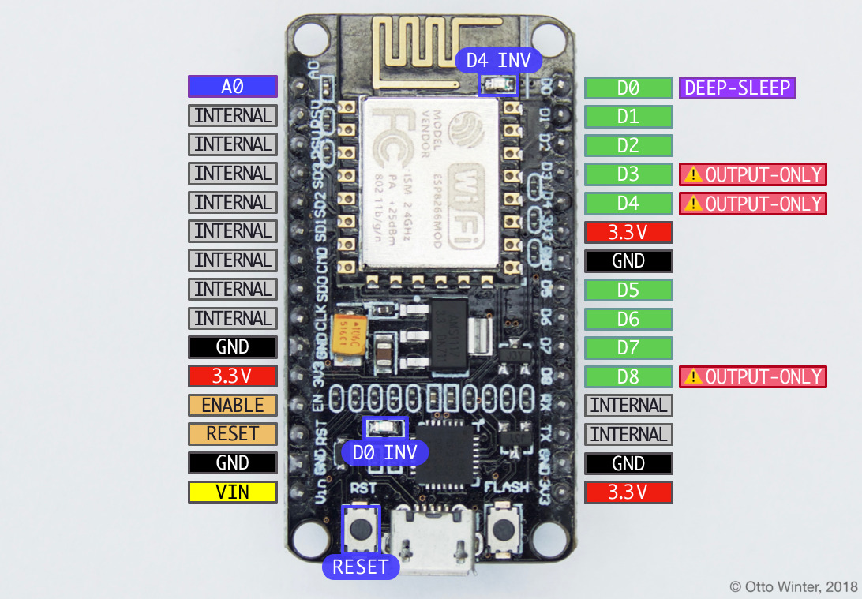

##### **4.Data Management with ThingWorx**

ThingWorx is an Internet of Things (IoT) platform that provides a comprehensive suite of tools and services for managing and analyzing IoT data. It offers robust capabilities for data management, storage, and analysis, making it suitable for handling large volumes of data generated by connected devices and sensors. Here's how ThingWorx facilitates data management:

6.1 Data Collection and Ingestion:

ThingWorx enables the collection and ingestion of data from various sources, including sensors, devices, and external systems. It supports different communication protocols, such as MQTT, RESTful APIs, and OPC-UA, allowing seamless integration with a wide range of IoT devices and data sources. This capability ensures that data from diverse sources can be efficiently collected and fed into the platform for further processing.

6.2 Data Storage and Persistence:

ThingWorx provides data storage and persistence capabilities to store IoT data securely.

It leverages a scalable and distributed architecture that can handle high volumes of data. The platform supports both time-series and relational databases for storing structured and unstructured data. This flexibility allows users to choose the appropriate data storage option based on their specific requirements.

6.3 Data Processing and Analytics:

ThingWorx offers advanced data processing and analytics capabilities for extracting insights from IoT data. It provides a visual development environment that enables users to define data processing workflows, perform real-time data transformations, and apply analytics algorithms. Users can create custom analytics models or leverage pre-built analytics functions to gain valuable insights from the collected data.

6.4 Data Visualization and Dashboards:

ThingWorx allows users to create intuitive and interactive visualizations of IoT data. It provides a wide range of widgets and charting options that enable the creation of dynamic dashboards and reports. These visualizations can be customized to display realtime data, historical trends, and key performance indicators, providing stakeholders with a clear understanding of the data and facilitating informed decision-making.

6.5 Data Access and Integration:

ThingWorx provides RESTful APIs and SDKs that allow seamless integration with external systems and applications. This enables users to access IoT data and share it with other enterprise systems, such as ERP, CRM, or data analytics platforms. The platform supports bidirectional data exchange, allowing data from external systems to be ingested into ThingWorx for further processing and analysis.

6.6 Data Security and Governance:

ThingWorx prioritizes data security and offers robust features for data protection. It provides role-based access control, data encryption, and secure communication protocols to ensure data confidentiality and integrity. The platform also supports compliance with data privacy regulations, allowing users to define data governance policies and manage consent and data usage permissions.

6.7 Scalability and Cloud Deployment:

ThingWorx is designed to be highly scalable, allowing it to handle millions of connected devices and large amounts of data. It can be deployed on-premises or on cloud infrastructure, providing flexibility and scalability based on the organization's requirements. Cloud deployment options include public cloud platforms, private cloud setups, or hybrid cloud configurations.

In summary, ThingWorx offers comprehensive data management capabilities for handling IoT data. It facilitates data collection, storage, processing, analytics, visualization, and integration, empowering organizations to leverage their IoT data effectively and derive actionable insights for improved decision-making and operational efficiency.

**5.DEVICE**

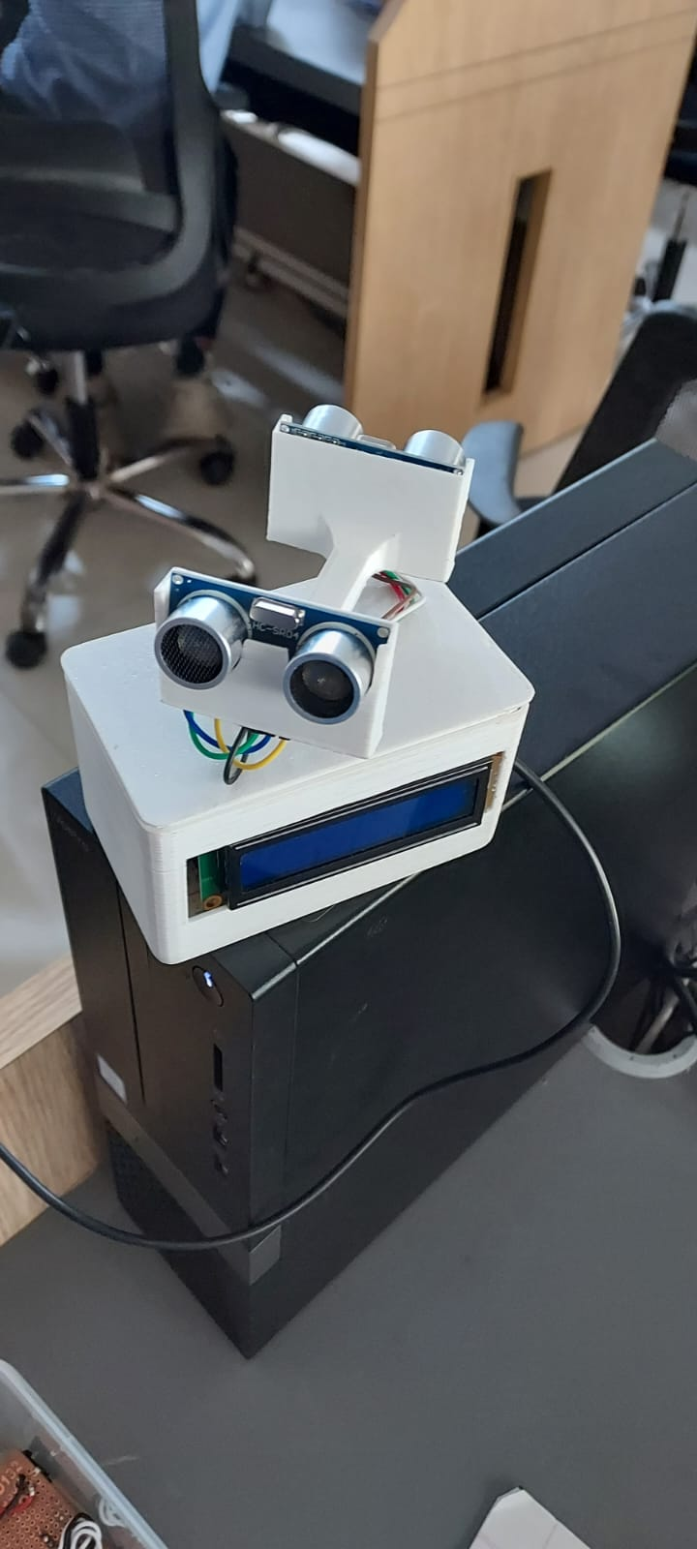

6.CONCLUSION

In conclusion, the animal intrusion device incorporating two ultrasonic sensors, a servo motor, a buzzer,

and an I2C LCD offers an effective solution for preventing animals from entering restricted areas. The

device addresses the limitations of existing solutions by providing accurate detection, comprehensive

coverage, real-time feedback, and active deterrence.

The ultrasonic sensors play a crucial role in detecting the presence of animals and accurately measuring

their distance from the device. This information is used to trigger the servo motor, which rotates the sensors horizontally, expanding the coverage area and minimizing blind spots. The integration of a buzzer

provides an auditory deterrent, emitting a high-intensity sound to discourage animals from approaching

the protected zone.

Additionally, the inclusion of an I2C LCD display enhances the device's functionality by providing real-time

feedback, sensor readings, and system status. This visual feedback allows for immediate monitoring,

configuration, and assessment of the device's performance.

By combining these components, the animal intrusion device offers an advanced and versatile solution

for deterring animals and protecting restricted areas. It improves detection accuracy, expands the

coverage area, provides an effective deterrent mechanism, and enhances user experience through

real-time visual feedback.

The affordability and widespread availability of components like the ESP8266 board further contribute

to the practicality and accessibility of implementing such a device. Overall, the animal intrusion device

with its integrated ultrasonic sensors, servo motor, buzzer, and I2C LCD provides an efficient and

customizable solution for mitigating human-wildlife conflicts and maintaining safety in animal-sensitive

environments.